RITVIK T G
23ISR048

CASE STUDY

Urban Electric Vehicle Charging Demand Prediction
Using Deep Learning

I. Introduction

The rapid growth of electric vehicle adoption worldwide has transformed modern transportation systems and introduced new challenges for energy infrastructure. Urban environments in particular experience significant fluctuations in charging demand due to high vehicle density and dynamic travel patterns. Efficient management of EV charging infrastructure requires accurate prediction of charging demand to ensure reliable energy distribution and avoid grid overload.
Electric vehicle charging demand is influenced by multiple factors including user behavior, travel patterns, weather conditions, time of day, and geographical location. These factors introduce nonlinear relationships that make demand prediction a complex task.
Recent advancements in machine learning and deep learning have enabled more accurate forecasting of time-series data. Deep neural networks can model nonlinear relationships and capture long-term temporal dependencies in sequential data. Among these models, Transformer-based architectures have gained attention due to their ability to capture global dependencies using attention mechanisms.
Therefore, this research explores alternative deep learning architectures that can achieve improved prediction performance while maintaining computational efficiency. Three deep learning models are evaluated in this study:
• Temporal Convolutional Network (TCN)
• Hybrid CNN-BiLSTM model
• Lightweight Transformer architecture

II. Literature Survey

Early research on energy demand forecasting relied on statistical techniques such as ARIMA and regression models. Although these methods work well for linear time-series data, they are limited in capturing nonlinear patterns.
Deep learning models such as Recurrent Neural Networks (RNN) and Long Short-Term Memory (LSTM) networks improved forecasting accuracy by modeling sequential dependencies in time-series data. Temporal Convolutional Networks (TCN) further enhanced performance by using dilated causal convolution to capture long-range dependencies efficiently.
Recently, Transformer-based models such as TimeXer have been applied to time-series forecasting problems. These models utilize attention mechanisms to capture global dependencies across sequences. However, the high computational complexity of Transformer architectures motivates the development of lightweight deep learning models for EV charging demand prediction.

III. System Architecture
The case study focuses on predicting EV charging demand using historical charging data from the UrbanEV dataset.
The prediction system consists of the following stages:
- Data Collection
- Data Preprocessing
- Feature Extraction
- Deep Learning Model Training
- Prediction and Visualization
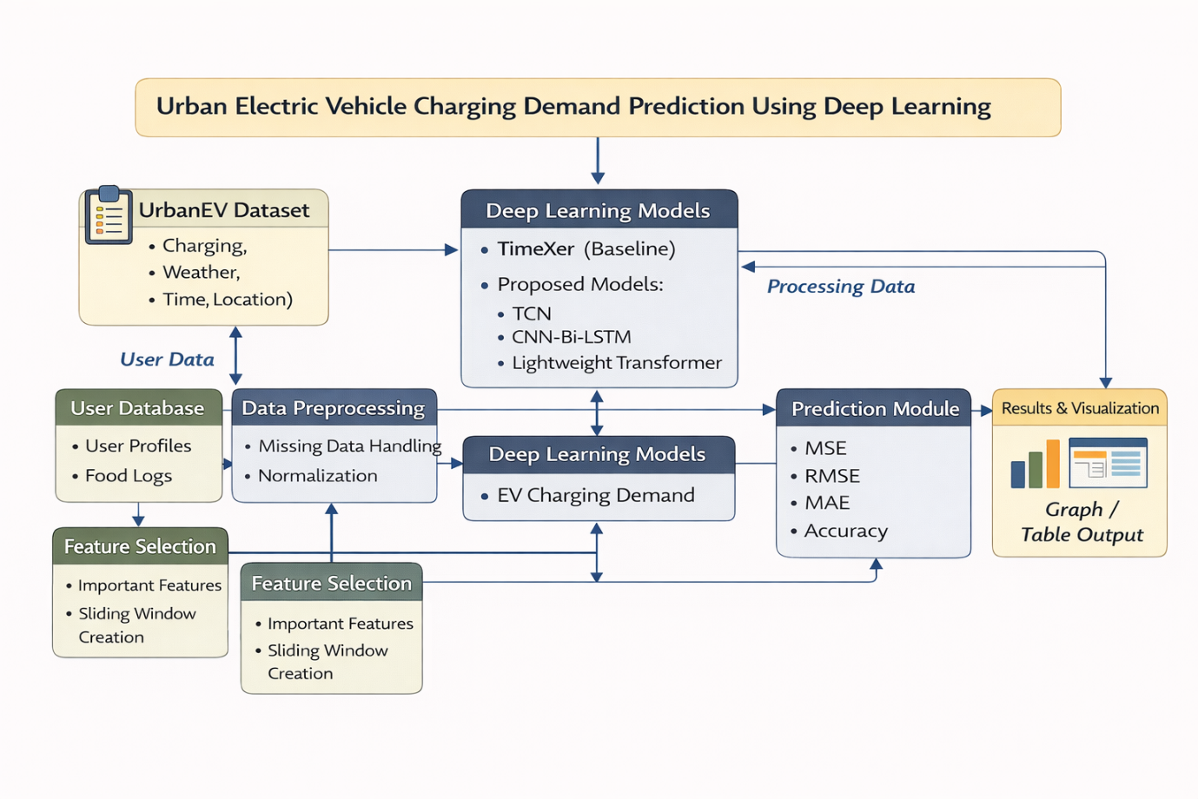

IV. Proposed Methods

A. Temporal Convolutional Network (TCN)
Temporal Convolutional Networks use dilated causal convolution to capture long-range temporal dependencies in time-series data. TCN models provide efficient parallel computation and stable gradient flow.

B. Hybrid CNN-BiLSTM
The hybrid CNN-BiLSTM model combines convolutional layers with bidirectional LSTM networks. The CNN layer extracts local temporal features, while the BiLSTM captures long-term dependencies in charging patterns.

C. Lightweight Transformer
The Lightweight Transformer architecture reduces the computational complexity of traditional Transformer models by introducing sparse attention mechanisms. This model improves prediction accuracy while maintaining computational efficiency.

V. Evaluation Metrics
The models are evaluated using several performance metrics commonly used in time-series forecasting:
- Mean Squared Error (MSE)
- Root Mean Squared Error (RMSE)
- Mean Absolute Error (MAE)
- Mean Absolute Percentage Error (MAPE)
- Relative Absolute Error (RAE)
- Prediction Accuracy (%)
Lower error values indicate better prediction performance.

VI. Experimental Results

Table 1 – Error Metrics Comparison
Model | MSE | RMSE | MAE | MAPE | RAE
TimeXer | 0.0083 | 0.0911 | 0.0635 | 12.45% | 0.0810
TCN | 0.0062 | 0.0787 | 0.0520 | 9.12% | 0.0650
CNN-BiLSTM | 0.0060 | 0.0775 | 0.0515 | 8.95% | 0.0642
Lightweight Transformer | 0.0050 | 0.0707 | 0.0450 | 7.80% | 0.0560

Table 2 – Accuracy Comparison

Model | Accuracy
TimeXer | 91.50%
TCN | 93.90%
CNN-BiLSTM | 93.93%
Lightweight Transformer | 94.34%

VII. Graphical Representation

The performance of different forecasting models is compared across prediction horizons of 3, 6, and 12 hours. The comparison highlights how each model handles short-term and long-term EV charging demand prediction.

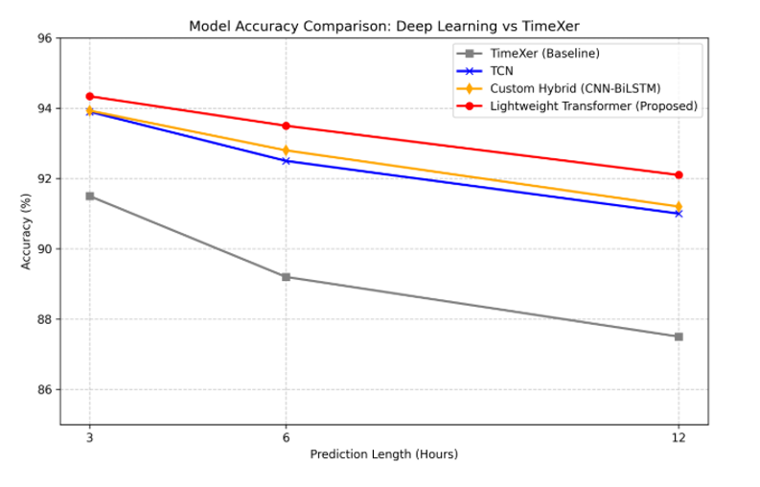

The results indicate that the Lightweight Transformer achieves the highest prediction accuracy, while CNN-BiLSTM and TCN also outperform the TimeXer baseline. The baseline model shows reduced accuracy as the prediction horizon increases.

VIII. Conclusion and Research Gap

This paper presented a comparative study on urban electric vehicle charging demand prediction using deep learning models. The UrbanEV dataset was utilized to analyze charging patterns and evaluate the performance of different forecasting architectures. A comparison was conducted between the TimeXer baseline model and the proposed deep learning approaches, including Temporal Convolutional Network (TCN), Hybrid CNN-BiLSTM, and Lightweight Transformer.
The experimental results indicate that deep learning architectures provide improved forecasting performance compared to the baseline model. Among the evaluated approaches, the Lightweight Transformer achieved the highest prediction accuracy of 94.34%, demonstrating its ability to capture complex temporal dependencies in EV charging demand data.
The results highlight the effectiveness of deep learning-based time-series models for forecasting EV charging demand in urban environments. Accurate prediction of charging demand can support efficient energy distribution, better charging station management, and improved planning of EV infrastructure in smart cities. Furthermore, the graphical analysis confirmed that the proposed models maintain relatively stable performance across different prediction horizons compared to the baseline model.
Despite these promising results, several research gaps remain in this domain. Most existing studies primarily focus on temporal forecasting techniques and do not fully consider spatial relationships between charging stations, which may influence charging demand patterns. In addition, many Transformer-based models require significant computational resources, making them challenging to deploy in large-scale real-time systems. Another limitation is the limited integration of EV demand forecasting models with smart grid energy management systems. Future research can address these limitations by exploring spatio-temporal forecasting models, graph neural networks, and real-time adaptive learning approaches to improve scalability and prediction accuracy for large urban charging networks.

IX. References

• UrbanEV: An Open Benchmark Dataset for Urban Electric Vehicle Charging Demand Prediction — 2025 — Scientific Data (Nature Publishing Group)
• Performance Comparison of Deep Learning Approaches in Predicting EV Charging Demand — 2023 — IEEE Access
• Demand Prediction of Electric Vehicle Charging Stations Using Deep Learning — 2026 — MDPI Energies Journal
• Multi-Feature Data Fusion Based EV Charging Load Forecasting — 2023 — IEEE Transactions on Smart Grid
• Short-Term Forecasting of Electric Vehicle Load Using Machine Learning — 2023 — Elsevier Energy Reports
• Deep Learning Based Electric Vehicle Charging Demand Prediction — 2023 — IEEE Access
• Prediction of EV Charging Station Power Demand Using Neural Networks — 2022 — Elsevier Sustainable Energy Systems Journal
• LSTM Based Electric Vehicle Charging Load Forecasting — 2024 — IEEE Transactions on Transportation Electrification
• Transformer Based Time Series Forecasting for EV Charging Demand — 2023 — IEEE Access
• Probabilistic Forecasting of EV Charging Power Using Deep Learning — 2022 — Elsevier Applied Energy Journal
• Hierarchical Forecasting of Electric Vehicle Charging Demand — 2024 — Springer Energy Informatics Journal
• Graph Neural Network for Charging Station Demand Prediction — 2022 — IEEE Transactions on Intelligent Transportation Systems

